# ITMD 463/563 Project 1

This is project 1.  Here is what you need to do:

You are going to build a four function calculator that hopefully looks better than this one/

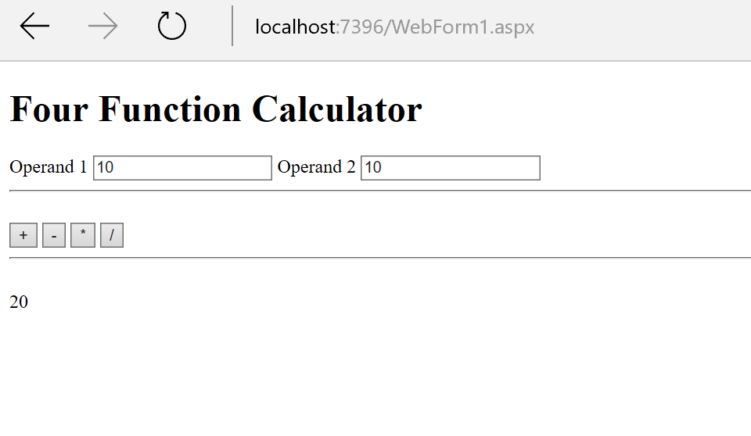

1. From the file menu pick File>New>Project﻿

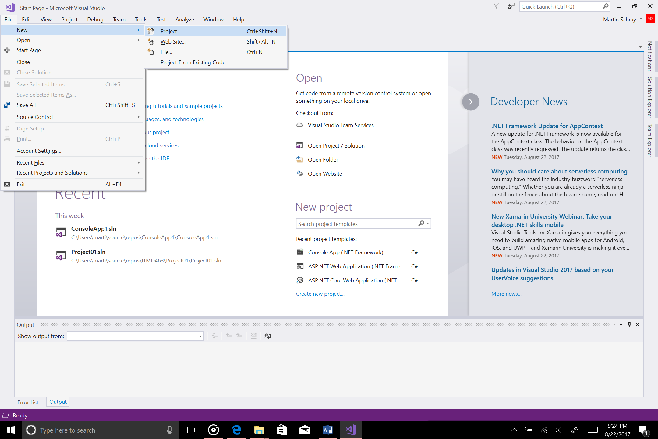

2. From the dialog that opens pick Web

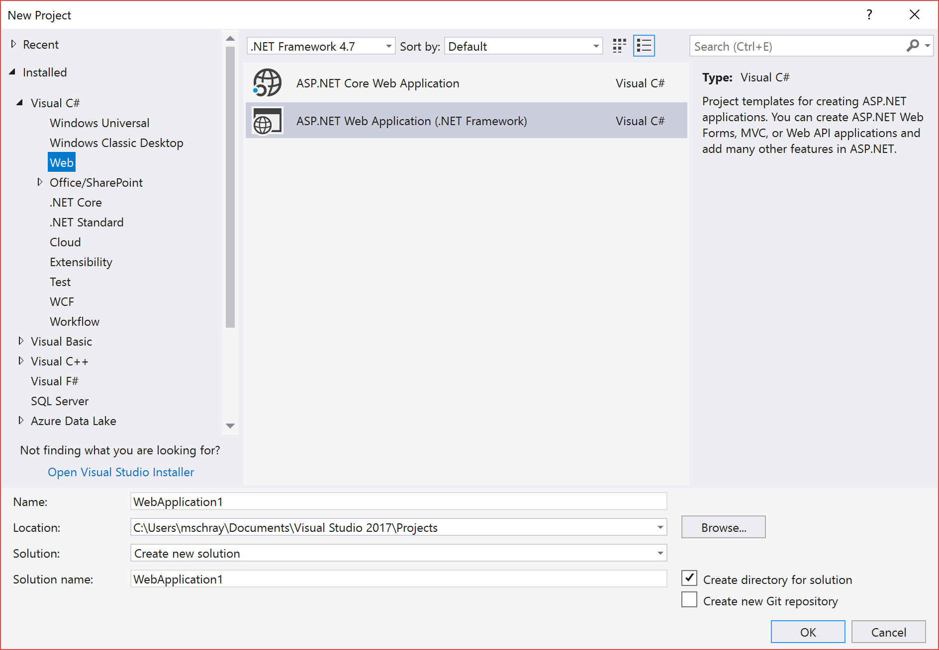

3. Pick the following project settings

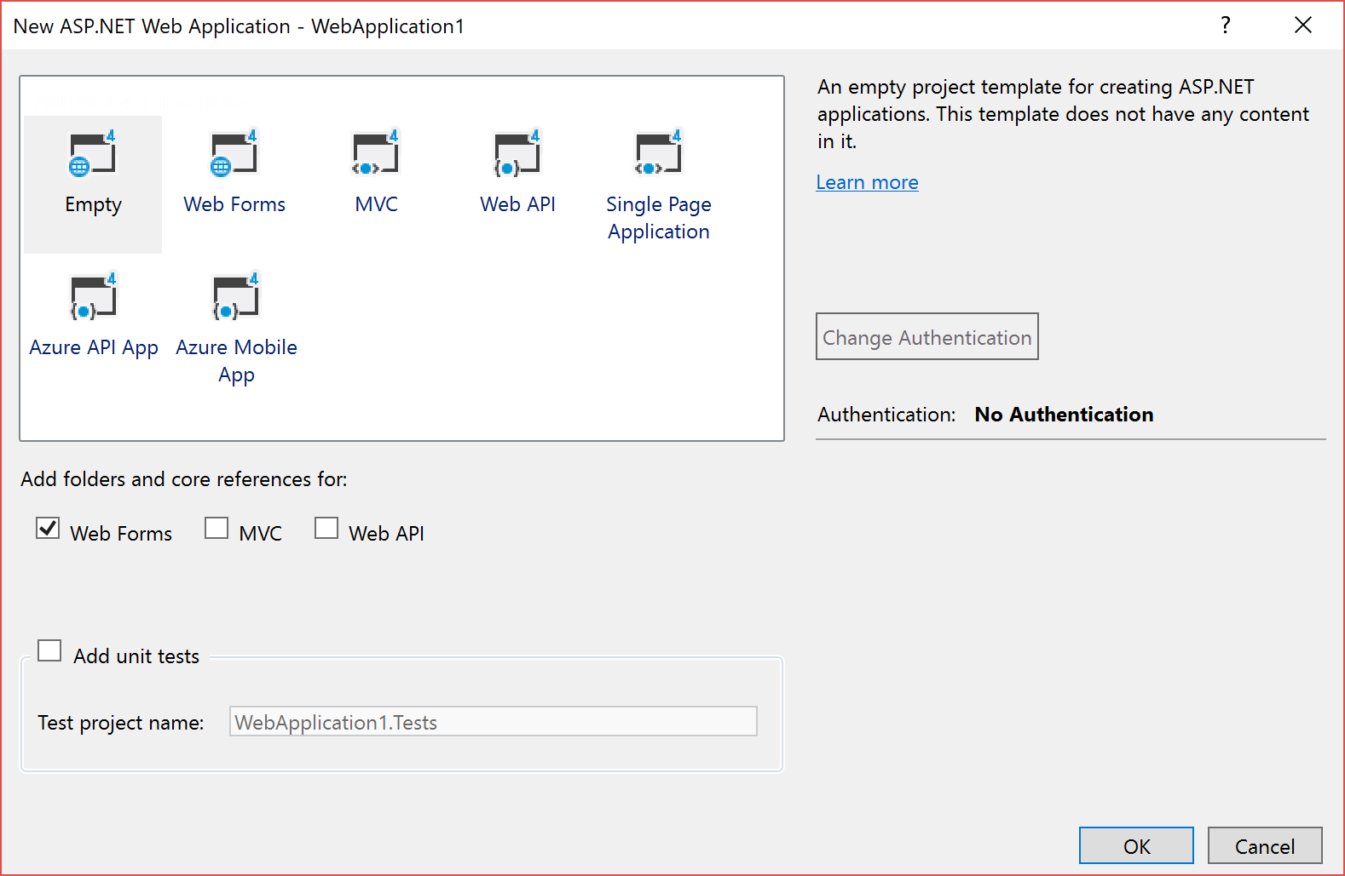

4. Pick Project>Add New Item and Web Form

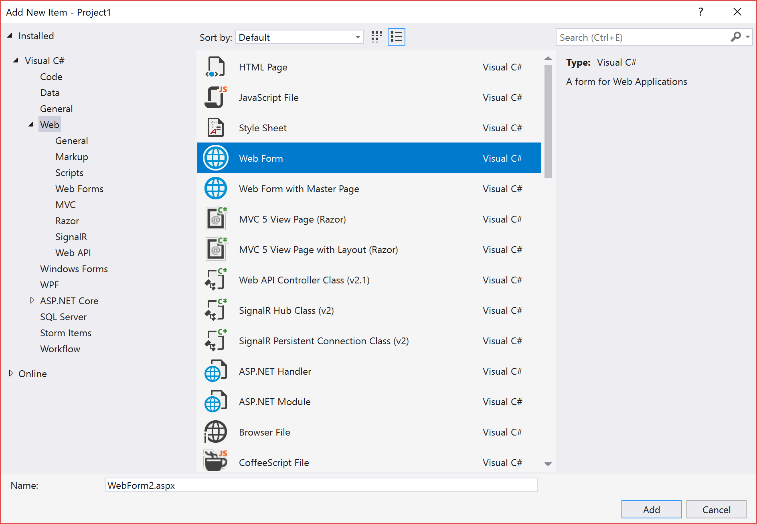

Build the four Function calculator based on what we have covered in class